Dear parents,

We’re Raring2go! for Winter, so please find our magazine link below file:///C:/Users/adminuser/Downloads/Raring2go!%20Harrogate%20.pdf It covers what’s on and things to do for families for December, January, and February…

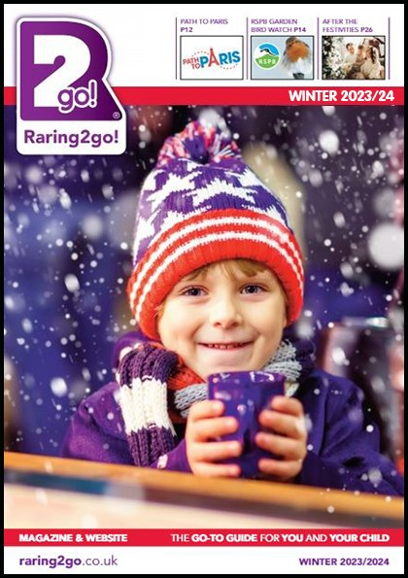

CLICK HERE FOR MAGAZINE LINK

We hope you enjoy doing all the activities and have lots of fun in the process!

Here’s wishing you all a very merry Christmas and an amazing New Year.

Best wishes
Raring2go!

