100 Books to Read Before You
Leave Year 6!
Matilda | Roald Dahl
Kensuke’s Kingdom | Michael Morpurgo
The Crossover | Kwame Alexander
Phoenix | S F Said
Charlotte’s Web | E B White
Alice’s Adventures in Wonderland | Lewis Carroll
The Lion, The Witch and The Wardrobe | C S Lewis
Stig of the Dump | Clive King
Artemis Fowl | Eoin Colfer
Diary of a Wimpy Kid | Jeff Kinney
Five Children and It | E Nesbit
Beetle Boy | M G Leonard
Clockwork | Phillip Pullman
The Secret Garden | Frances Hodgson Burnett
Wonder | R J Palacio
The Borrowers | Mary Norton
The Fantastic Flying Books of Mr. Morris Lessmore | William Joyce
Skellig | David Almond
A Series of Unfortunate Events | Lemony Snicket
The Girl of Ink and Stars | Kiran Millwood
Holes | Louis Sachar
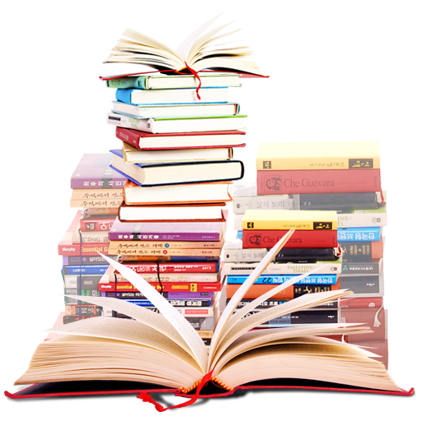  Demon Dentist | David Walliams
Goodnight Mr. Tom | Michelle Magorian
Inside Out and Back Again | Thannha Lai
The Suitcase Kid | Jacqueline Wilson
The Boy in the Striped Pyjamas | John Boyne
Firegirl | Tony Abbott
The Many Worlds of Albie Bright | Christopher Edge
Percy Jackson and the Lightning Thief | Rick Riordan
Coraline | Neil Gaiman
Journey to the River Sea | Eva Ibbotson
Five on a Treasure Island | Enid Blyton
Time Travelling with a Hamster | Ross Welford
Room 13 | Robert Swindells
A Monster Calls | Patrick Ness
Millions | Frank Cottrell-Boyce
Street Child | Berlie Doherty
Cogheart | Peter Bunzl
Cloud Busting | Malorie Blackman
Trash | Andy Mulligan
Harry Potter and the Philosopher’s Stone | J K Rowling
The Imaginary | A F Harold
Once. | Morris Gleitzmann
Groosham Grange | Anthony Horowitz
The Indian in the Cupboard | Lynne Reid Banks
The Nowhere Emporium | Ross MacKenzie
Oranges in No Man’s Land | Elizabeth Laird
Rooftoppers | Katherine Rundell
George’s Secret Key to the Universe | Lucy Hawking
Shadow Forest | Matt Haig
The Diamond of Drury Lane | Julia Golding
The London Eye Mystery | Siobhan Dowd
The Silly Book of Side-Splitting Stuff | Andy Seed
The Considine Curse | Gareth P Jones
Animal Farm | George Orwell
Flour Babies | Anne Fine
The Worst Children’s Jobs in History | Tony Robinson
The Amazing Maurice and his Educated Rodents | Terry Pratchett
The Wolves of Willoughby Chase | Joan Aiken
The Queen’s Nose | Dick King-Smith
Eren | Simon P Clark
The Hobbit | J R R Tolkien
Black Beauty | Anna Sewell
The Demon Headmaster | Gillian Cross
LionBoy | Zizou Corder
The Wind in the Willows | Kenneth Grahame
The Wind Singer | William Nicholson
When Hitler Stole Pink Rabbit | Judith Kerr
How to Train Your Dragon | Cressida Cowell
A Library of Lemons | Jo Cotterill
The Bubble Boy | Stewart Foster
Miss Peregrine’s Home for Peculiar Children | Ransom Riggs
The Boy Who Sailed the Ocean in an Armchair | Lara Williamson
Pax | Sara Pennypacker
My Brother is a Superhero | David Solomons
The Brilliant World of Tom Gates | Liz Pichon
Black Powder | Ally Sherrick
Sweet Pizza | G R Gemin
Swallows and Amazons | Arthur Ransome
Strange Star | Emma Carroll
Face | Benjamin Zephaniah
Michael Rosen’s Sad Book | Michael Rosen
The Arrival | Shaun Tan
Ballet Shoes | Noel Streatfeild

