 | Directorate of Economy and Place  West Offices  Station Rise  YO1 6GA  T: 01904 551550
Wednesday 16th September 2026
BIKEABILITY CONSENT FORM

Learning to ride a bike safely is a major step in children’s lives, and we are pleased to be writing to let you know that your child’s school has booked Bikeability training with City of York’s road safety team.

Each child will have the opportunity to take part in a Bikeability Level 1 and 2 Combined Cycle Training Course which will take place during school time. This course is designed for children who are already able to cycle. To progress to Level 2, your child must meet the Level 1 outcomes and the instructors need to be confident your child will be safe on public roads. If for any reason this is not the case, we will try to provide additional instruction on the playground (dependant on instructor availability). You can read more about the levels below:

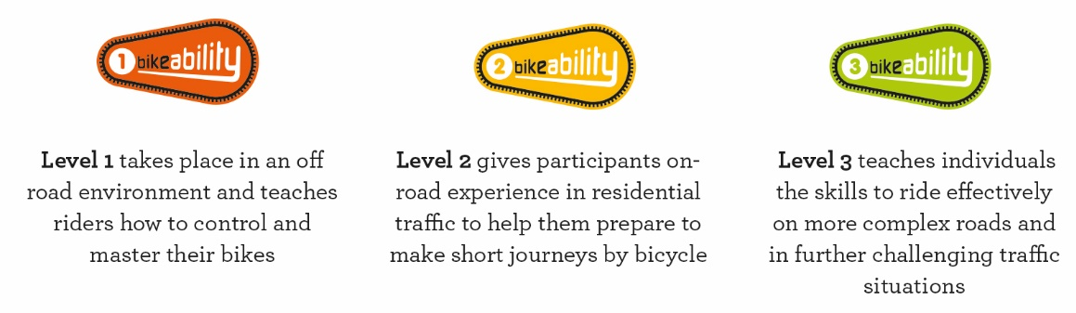

What is Bikeability?
Bikeability is the government’s national cycle training programme. It helps build practical skills and understanding of how to cycle on today’s roads. Bikeability gives everyone the confidence to cycle and enjoy this skill for life.

Bikeability can not only make children better cyclists - potentially for the rest of their lives - but can help with general confidence and independent thinking. To find out more, visit www.bikeability.org.uk

Dates:
Group 1: Thursday 1st, 8th, 15th and 22nd October
Group 2: Thursday 5th, 12th, 19th and 26th November
Parents will receive a text to let them know which group their child is in and when their child should bring their bike and helmet to school with them.

Cost – We ask for a voluntary donation of a recommended £10 per child. Please follow the link and click on the red button to make a payment. By making a voluntary donation you are helping to ensure the future of Bikeability in the City of York primary schools.
https://www.york.gov.uk/BikeabilityTraining

What will each child need?
- Permission to take part in Bikeability by submitting the digital consent form. This is completed using an electronic link or QR code which is linked below. Please note that Bikeability places may be limited, and places will be booked on a first come basis. Your child will not be able to take part if they do not have digital consent.
- Suitable clothing for the weather conditions (eg coat, gloves if cold)
- Pupils will need to bring a roadworthy bike on the day of training or indicate if you would like your child to use a loan bike.
- We require all children taking part in the training to wear a cycle helmet that fits securely. Loan helmets can be provided for the training on request. If there is a reason your child cannot wear a helmet please inform their school.

A roadworthy bike has:
- Inflated tyres, as hard as an apple
- Two working brakes
- A well-oiled chain
- A saddle and handlebars which are fixed on tight

For tips on how to check your bike is roadworthy, visit https://bikeability.org.uk/bikeability-training/get-ready/ . If you are still unsure, please seek the advice of a professional mechanic in advance of Bikeability cycle training.

To complete the online consent form, please scan the QR code, or follow this link: https://consent.bikeability.org.uk/fraud-tad-route

The consent form must be completed by Tuesday 22nd September 2026.

If you have any further questions, please contact your child’s class teacher.

Kind regards,
Miss Cattley
(Year 5/6 class teacher)

